ASCII CODE

It is a language in which we address the computer, that is, it converts human language into a language that the computer understands. It also symbolizes each letter with a number or a specific symbol, such as: a=97. We also use it to convert from one data type to another or convert from one symbol to another.

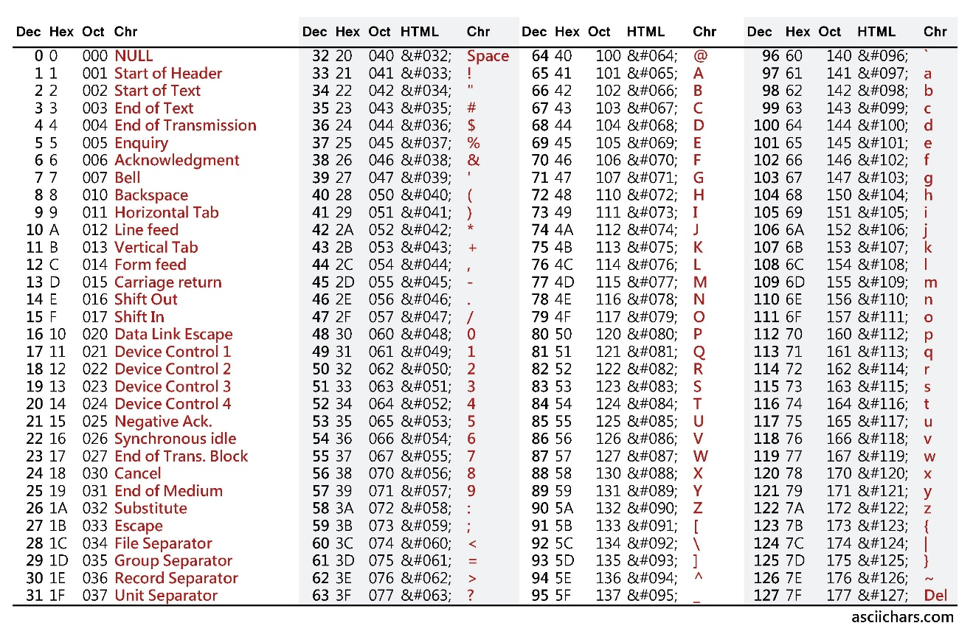

This is an example how to convert the capital latter A to small latter a:

